

Genre :
Adventure game with math-based puzzles

High Concept :
Teach players a variety of fundamental linear algebra concepts through a series of game exercises.

3. Back Story :
You play a pirate stranded on a deserted island. Your goal is to rebuild your pirate ship. On this adventure, the player will enter different worlds that need to be solved using linear algebra. Each world focuses on a different concept of linear algebra. Upon successful completion of a world, a piece of the ship will be rewarded to the player. The player’s ship is located on the central hub world. The status of the ship is determined by how many worlds have been completed. The ship is fully repaired upon successful completion of all puzzles.

4. Target and Platform :
The game is built for web browsers on PC or Mac using Unity’s WebGL support. Supports both keyboard-and-mouse for desktop users or keyboard-only for laptop users.

5. Game Play :
The player character solves linear algebra problems in order to gain the parts needed to repair their ship. The main play space is a hub world where the player has the freedom to tackle linear algebra concepts in whatever order they choose. The puzzles themselves involve different concepts of linear algebra. One level teaches players vector displacement, requiring the player to properly calculate displacement in order to cross a chasm. Another teaches them about linear spans using a rolling ball, and so on and so forth. The game is presented in third-person with a free roaming camera, and allows basic movement from the player, with the player being able to run in any direction as well as a basic jump. The player can also switch to a top-down camera angle for a better overview of each level.

6. GUI :

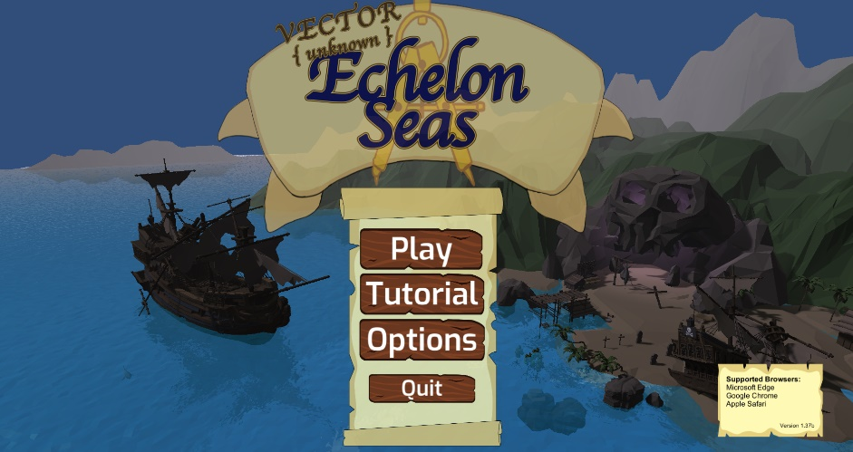
Main Menu

Start Splash Screen
The first thing the player sees upon starting the game. This menu features 4 buttons:
- Play
  - Advances the Menu to the Login Window
- Tutorial
  - Loads a tutorial/basic controls level located on the hub world
- Options
  - Displays a starting Options screen for changes such display size and volume controls
- Exit
  - Exits the application. In browser this does not close the browser tab, only stops the WebGL player.

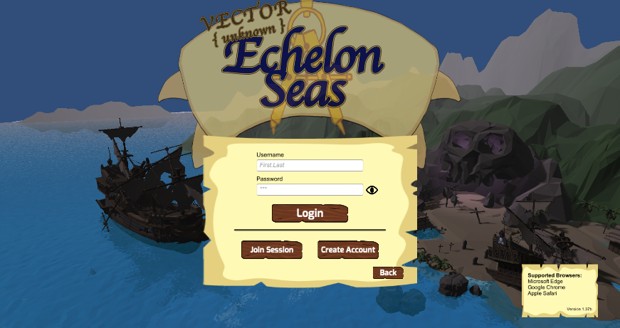
Login Window
The main login screen for the player. Here the player may enter in their Username/Password to login and continue a previous playthrough with their saved data. They may also Join a Instanced Session for things such as demos or classroom specific play throughs. More on both of these features in the Database Section. Lastly this page allows new players to create an account and will forward them to the new account creation screen.
After the player enters their information and clicks “Login” they will be dropped off in the Hubworld in front of the ship. If the user entering in their login information is an Admin user, they will instead be presented with an Admin splash page before entering the Hubworld.

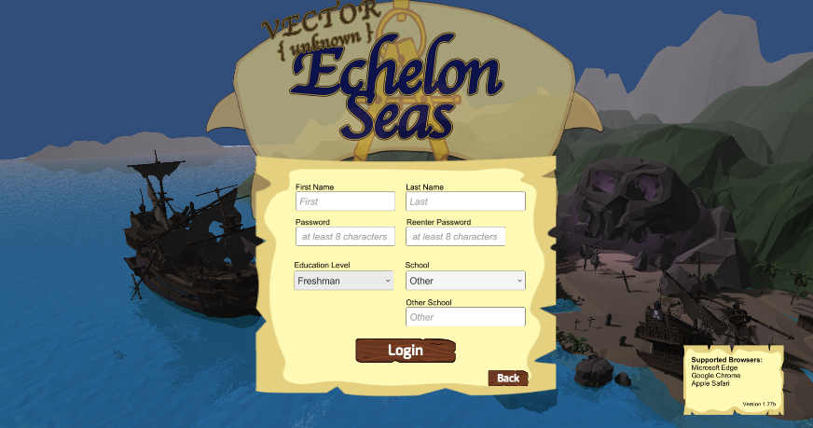
New Account Window
This screen allows new users to enter in their basic information to create a saveable player in the database. Very minimal user data is collected and is mainly used for correctly identifying the user account and associated research purposes to improve the game.
- First/Last Name
  - The player enters in their first and last name.
  - This will be used to create their Username for the Login Window by concatenating the two seperated by a “.” (ex: John.Smith, Mary.Sue)
  - In the event that a previous user has the same username, the new user will have a number assigned to their username (ex: John.Smith4, Mary.Sue1)
- Password
  - Password generation requires that the password be at least 8 characters long
  - The dual entry checks the first with the last to ensure there are no mistakes in saving
  - This password is saved using a PBKDF2 salted hash encryption
  - This password is non-recoverable if lost
- Education
  - The users current education level. We assume the user to be in College, although the entries could be extended for High School use.
- School
  - Primary acting schools are selectable in the drop down menu, or the player may manually enter their school by selecting “other”.
  - When “other” is selected a final input box appears allowing the user to manually type their school

InGame UI Elements

Pirate’s Log :
A navigable on screen interface that displays the math concepts involved and associated examples. The log serves as a “textbook” relaying the more in-depth math involved and steps for solving those problems.

Dialogue :
Instructs the player in how to complete puzzles and levels. Also provides story context and overall objective of the game.

Dialog Boxes appear as a rectangular box in the center lower screen. Each box features a caricature of the NPC speaking, the NPC’s name, the dialog, and a button to progress the diaglog/close the dialog at the end.

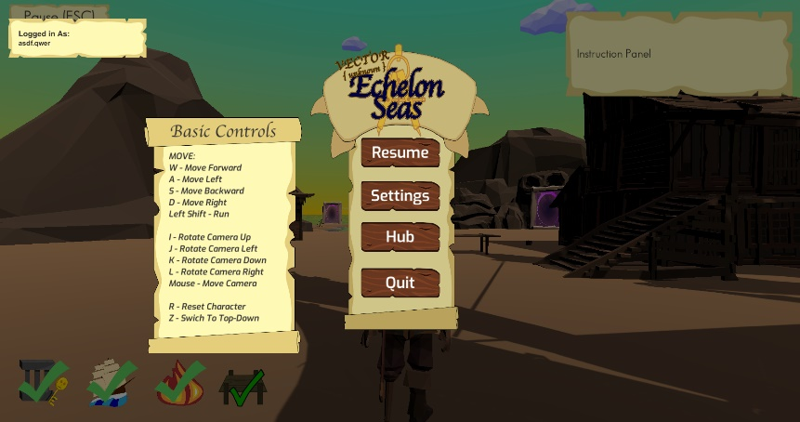
Pause Menu :
The pause menu (accessed by pressing “Esc” on the keyboard) features 3 Key elements.
- Logged in Name
  - Static display in the Top Left corner
  - Relays the current logged in user’s “username”.
- Basic Controls
  - A static display on the center left.
  - Displays universal player controls information such as how to move and keyboard alternate controls to using the mouse.
- Options Buttons
  - Resume
    - Exits the pause menu and returns the user to the game.
  - Settings
    - Opens an Options Menu similar to the one accessed from the Main Window.
    - These options will be saved to the player’s account so once they set them, they are retained for their next login.
  - Hub
    - Exits the player from any Puzzle Stage and returns them to the Hubworld.
  - Quit
    - Logs the Player out and returns them to the Main Window Splash.

In-Game UI :
Where the math gameplay mechanics reside. All puzzles rely on UI for solving their relevant math concepts. These vary between click-and-drag and sliders to successfully solve problems.

7. Levels :

Hub Island and Tutorial
A singular island hub displaying the crashed pirate ship. On this island are multiple portals to other stages. The hub world will serve as the player homebase and mechanic learning area. Here the tutorial stage for basic moving controls will exist.
The crashed pirate ship will be rebuilt as the player completes different worlds. As the player collects rewards from solving different problems, parts of the ship will be visually displayed showing their progress.
The tutorial area only covers basic movement mechanics, how to enter numbers and menu buttons. This is in no way meant to show every aspect of every world. Instead worlds will give their own brief introduction in the first level about their specific goals/mechanics.

Stage 01 - Vector Displacement Game
The player needs to navigate through an environment by selecting vectors to create ramps and bridges. The player starts on the ground and works their way up to the top of some scaffolding. At certain points they are given their destination vector and must calculate the appropriate vector displacement to reach this destination. Once solved successfully, a ramp or bridge appears and the player can progress. This repeats until they reach the final destination.

Question Generation
For this stage the questions are predetermined. Every playthrough will feature the same questions however the player may elect to answer them differently each time. The game checks the math against the expected answer and rewards the player if correct.
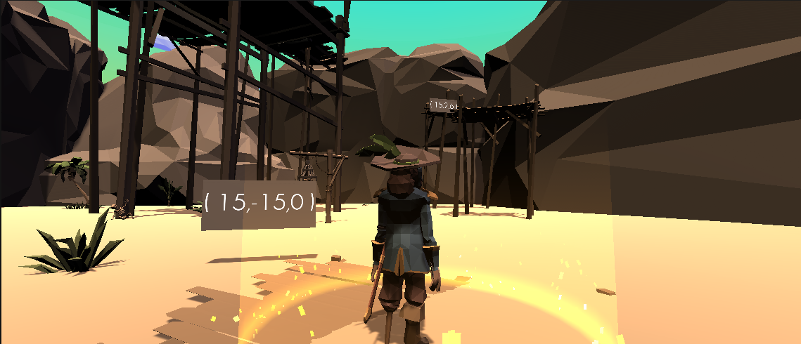

Stage 02 - Cannonball Game (Matrix Multiplication)
The player needs to hit a target with their ship’s cannon. They do so by selecting a 2x2 matrix, and then multiplying that by a 2x1 vector which determines the cannonball’s trajectory. The player shoots one ship at a time so they’re never overwhelmed. Once a ship has been successfully sunk, the next one becomes available to shoot at, or the player may elect to move on to a different ship/question by pressing “Q” on their keyboard. Repeat until all ships have been destroyed.

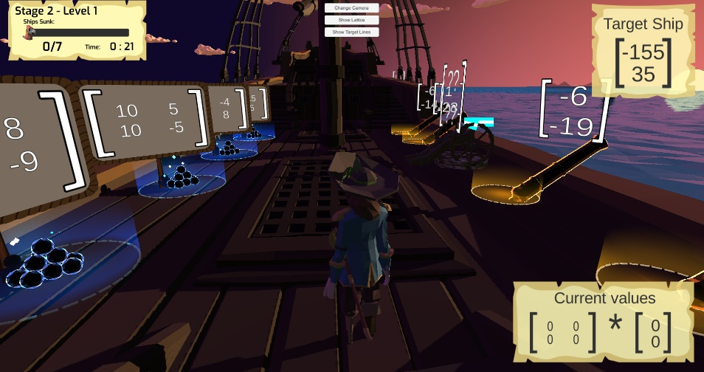
Question Generation
For this puzzle the game randomly generates the ship’s locations and then solves for solutions to each ship’s location. Each puzzle piece generates it’s own correct matrix and vector pair, then creates several red herring answers to shuffle into the gameplay area. For an extended view of the algorithm please see Appendix A.

Stage 2 - Level 1 :
This stage creates the matrices in a way so that the math is easier for the player to mentally calculate. The associated vectors may on be constructed using the set of numbers in the set:
$$V=\left\{ x,y \right|-1<x,y<1 and x=y≠0 \}$$
Additionally, the level attempts to make each value in the matrix some multiple of 5 (ex: 15, 75, 30, etc).

Stage 2 - Level 2 :
Similar to the first level, however the set for V is extended to reflect as:
$$V=\left\{ x,y \right|-3<x,y<3 and x=y≠0 \}$$
And the matrix generation is still set in the multiples of 5.

Stage 2 - Level 3 :
The final stage still continues to compute V as displayed above, however this stage does not make any accommodations for easy rounding. Instead the matrix may be any number of integers.

Stage 03 - Puzzle Ball (Vector Spans)
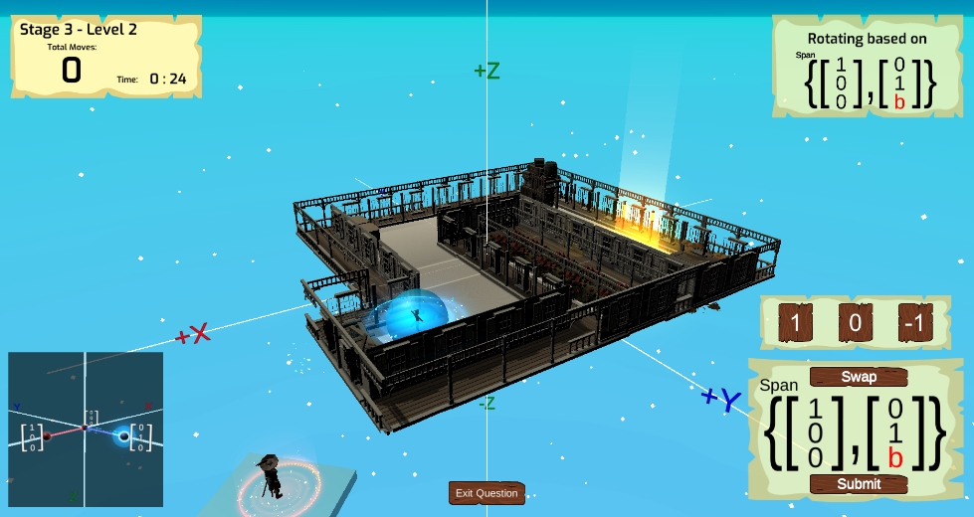
A roll-a-ball game where the player inputs different spans with the goal of rolling a ball through a maze-like environment from point A to point B. The environment’s rotation is controlled directly by the vectors that the player inputs. Vectors are selected on cards that the player drags onto the equation portion of the UI. The puzzles increase in difficulty as the player progresses. There are 3 puzzles to complete in order to finish the level, named Level 03-A, Level 03-B, and Level 3-C.

Question Generation
Because the stage is fixed as a game asset, the questions are static. However, the game still keeps this varied through playthroughs by rotating the play field by 90, 180, -90, 0. This means there are only 4 versions of any level.

Stage 3 - Level 1 :
The stage is a small playfield that only requires minimal manipulation of the Vector Spans to complete.

Stage 3 - Level 2 :
The stage is a medium playfield that only requires some manipulation of the Vector Spans to complete.

Stage 3 - Level 3 :
The stage is a large playfield that requires quick manipulation of the Vector Spans to complete.

Stage 04 - Grapple Game (Advanced Vector Displacement)
An extension of Level 01. The player uses a Grapple hook to maneuver through obstacles. The player will aim their hook (shown red) to counteract (displace) things such as the direction of the wind (shown blue) and physical gaps (shown green).
The initial two levels will be shown in a 2D side scroller format. This will still be rendered in 3D, only the camera will be removed to the side instead of behind the character. There is a grid view available to toggle on and off for players for a better representation of the math at work in the levels, as well as the ability to freely move the camera around to get an all-around view of the puzzle.

Question Generation :
The starting and anchor positions are fixed inside the game space, however the questions can use that distance information and make variations of it as a starting vector. It does this by taking in a suggested question vector, then makes small modifications of that initial entry. After this it solves for the new vector and creates an answer card, followed by additional red herring cards. The player is not required to use this answer card, so long as the player’s final answer arrives at the correct answer, the game will accept it and reward the player. For more detailed information on this, see Appendix B.

Stage 4 - Level 1:
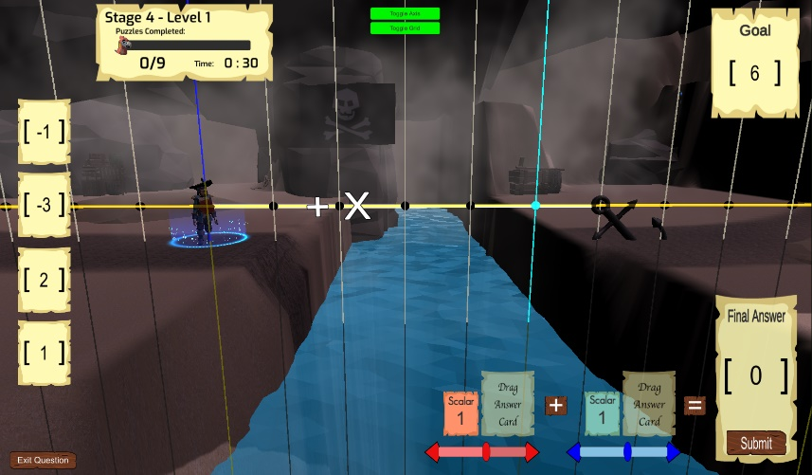
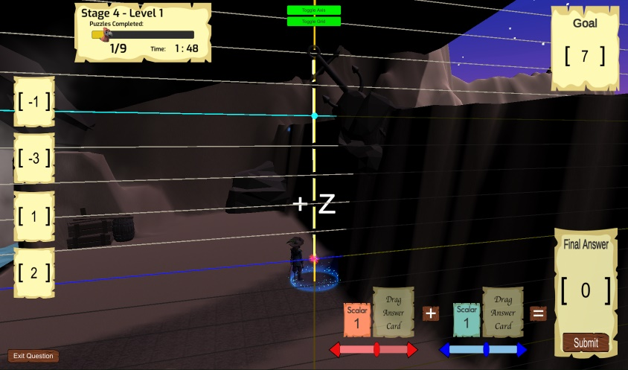
Introduces vectors in “One dimensional” space. The player will grapple onto one directional obstacle such as a pole or platform. The player may only grapple in the X or Z direction. This is to slowly introduce both the mechanic of the game, and vectors.

Stage 4 - Level 2:
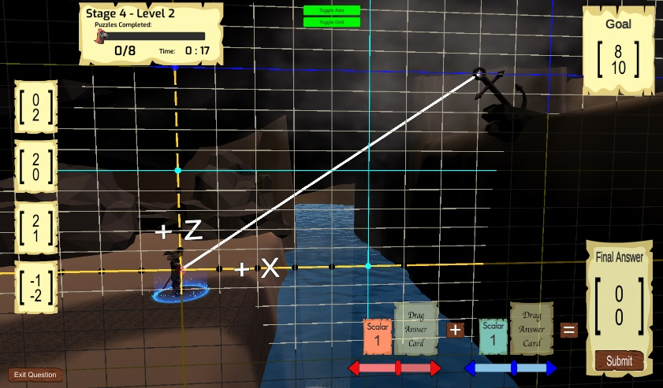
Introduces vectors in Two Dimensional space. Similar to 4-A, except we will now combine the two vectors into more advanced versions. The player will now use the grapple to move in XZ directions.

Stage 4 - Level 3 :
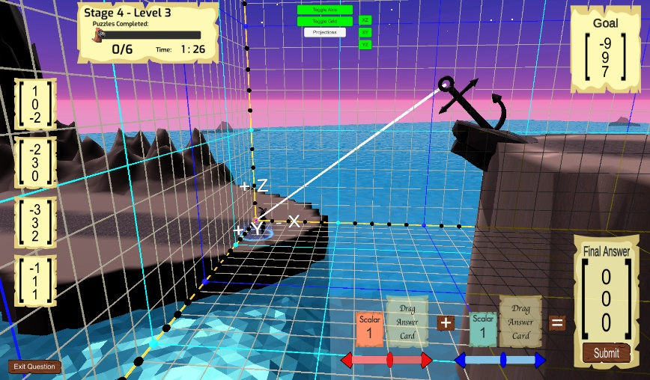
Introduces vectors in Three Dimensional space. The camera will be repositioned to the 3rd person view. Now the player may move in the XYZ direction with similar obstacles. Only now the player must displace their grapple hook shot in 3D space.

8. USP (Unique Selling Proposition):
List up several selling points
- Clean graphics (not like that of a cheap flashplayer game)
- Contains several linear algebra concepts instead of just one
- Fun way to practice linear algebra in and outside of the classroom
- Yields a reward other than just completing the level (getting ship parts)
- Beneficial for all levels of linear algebra knowledge
- “Non-gamer” friendly but also intuitive enough for seasoned gamers
- Playable on desktop or laptop

9. Competitive Analysis:

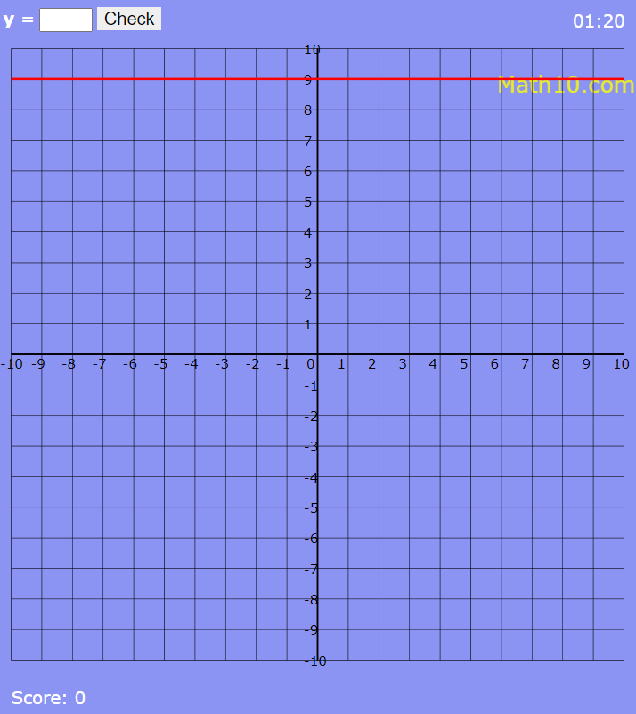
Line Graphs Game

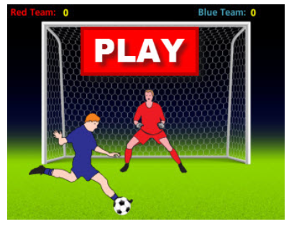

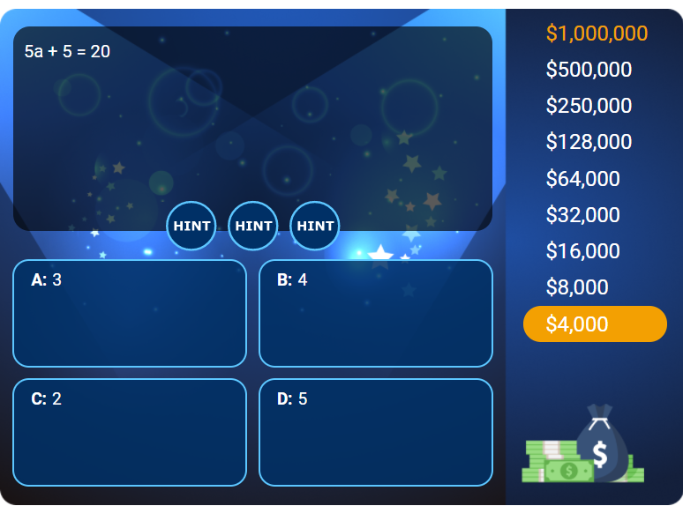
Rags to Riches

Equations Soccer Game

10. Budget:
N/A

11. Members:
Dana Lee
Christopher Olson
Ryan Hill
Rida Shiban
Ajai Gorowara
LaQuez Brown
Ryan Lapp

12. Summary:
Understanding linear algebra is essential to any computer science related occupation, especially game development, and our game aims to make learning its many concepts both more intuitive and more interactive. This project represents several semester’s worth of work, with each group building off the previous group’s work. Our primary goal is to get the game into a much better state through bug fixes, basic quality of life improvements both in-game and in regards to the code, better production value, and most importantly, to make the game as fun and informative as possible.

13. Concept Art:
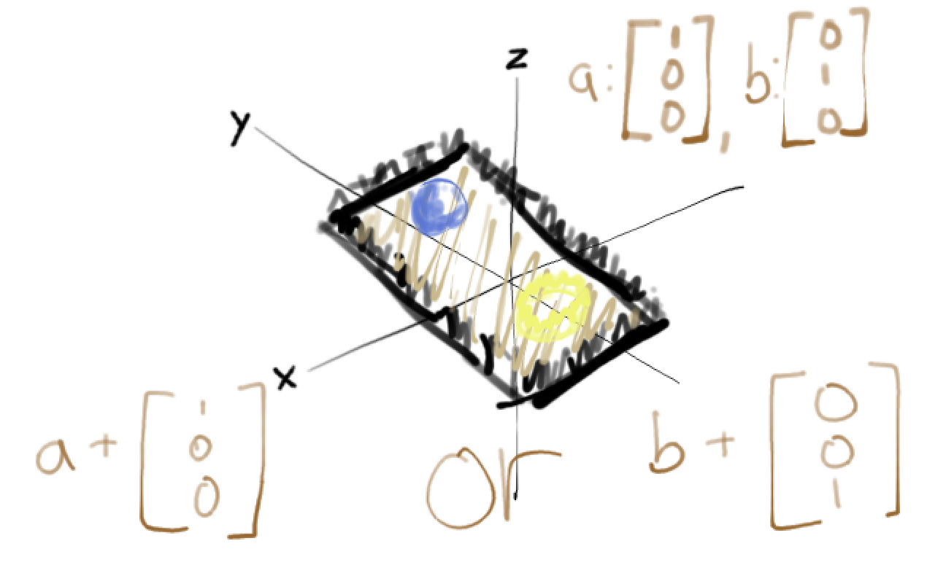

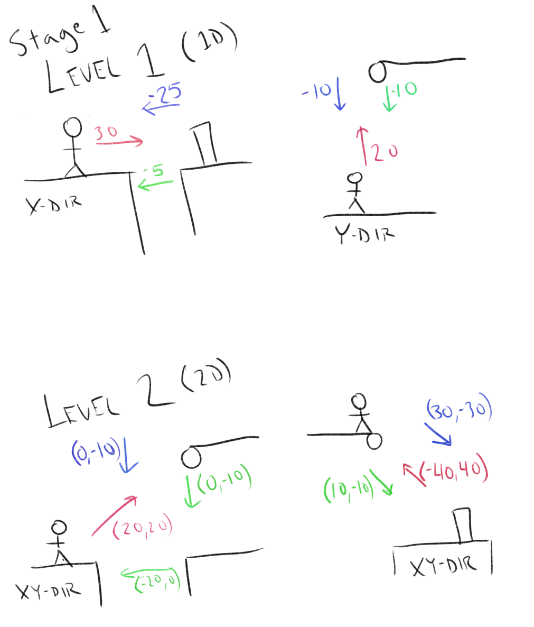

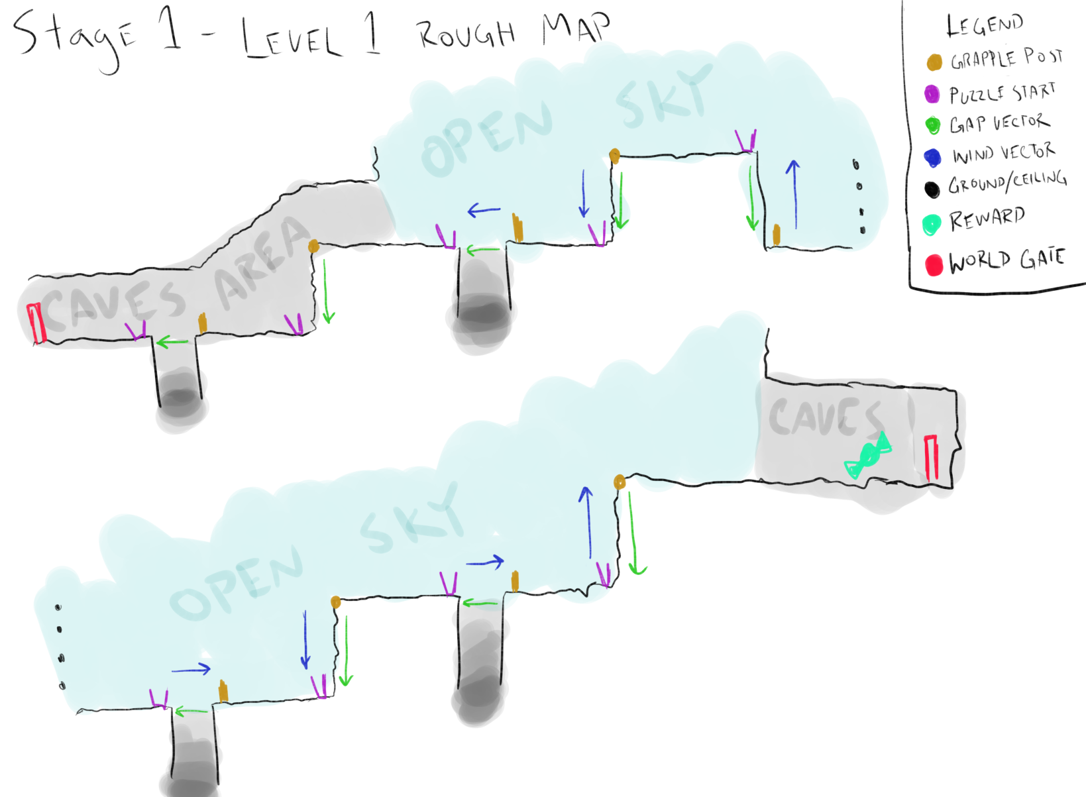

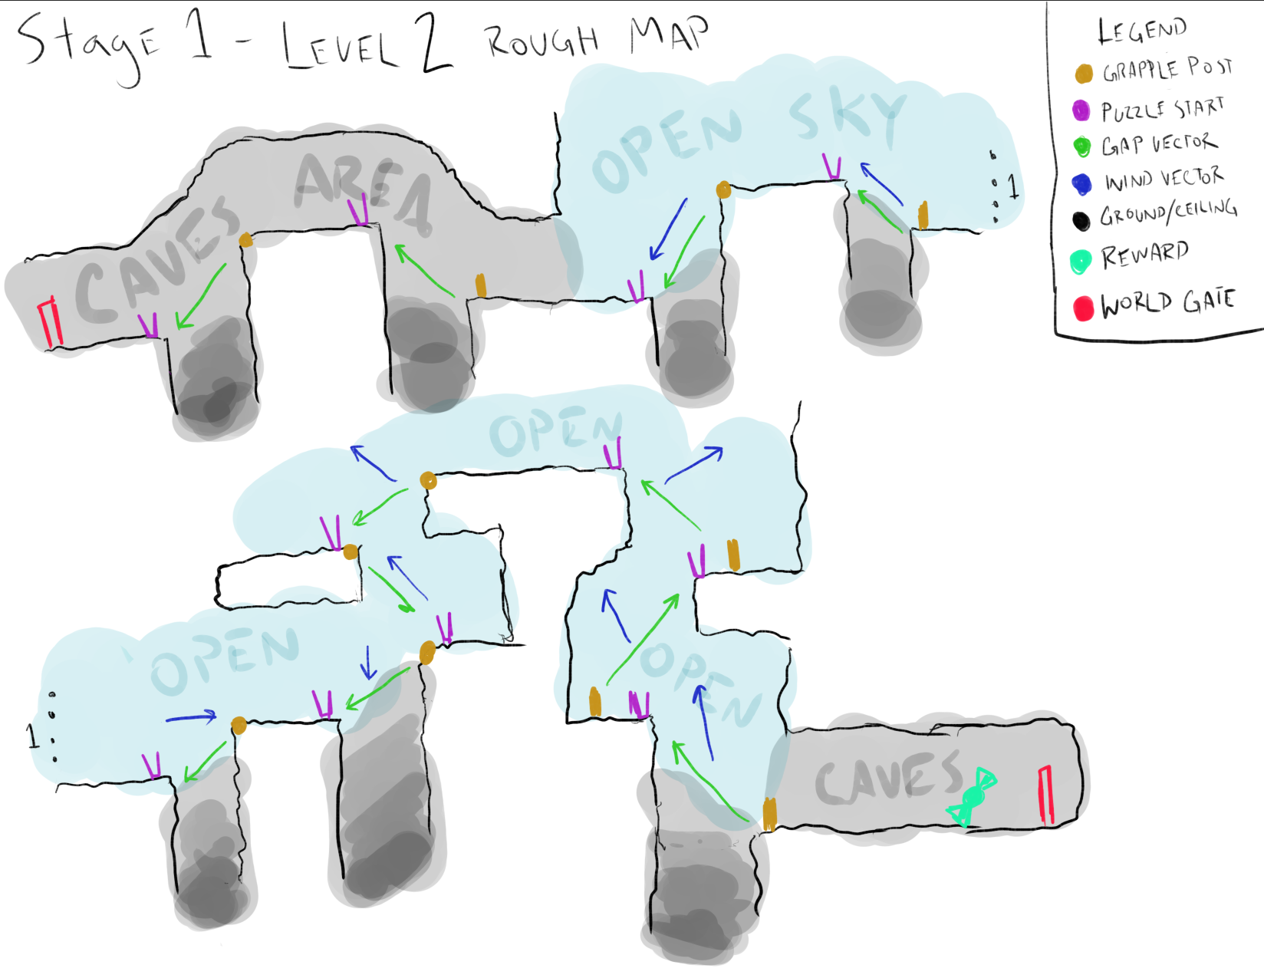

Appendix A:

